SCREEN SHOTS



Fig1 : Thank you page after registration.

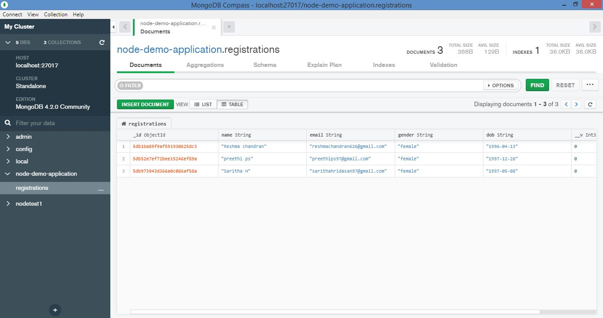

Fig 2 : Name, email ,date of birth, gender which is entered in the website is stored on mongo database in table format.

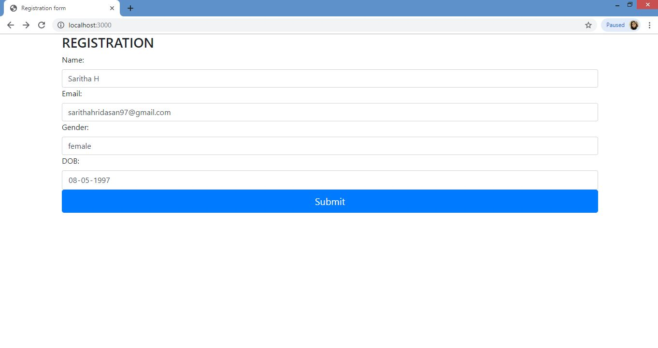

Fig 3 : This is how my registration form look like.